|  |  |
| --- | --- |
|  |  |
|  | Foundation Activity 5 Blinking an RGB LED Using a Microcontroller |

RGB LEDs

RGB LEDs contain a red, green and blue LED in one part:

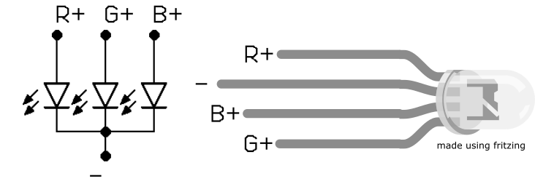

Controlling the Colour Using an Arduino Uno

In this activity, we will use an Arduino UNO microcontroller to switch the colour of the RGB LED from one colour to the next by connecting each one to a different digital output pin on the Arduino. Each colour will use its own resistor.

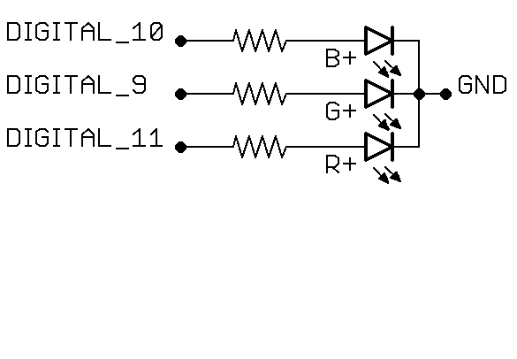

Programming the Arduino Uno

First, we write instructions for the Arduino on a computer, then upload those instructions to the Arduino using a USB cable.

[1] 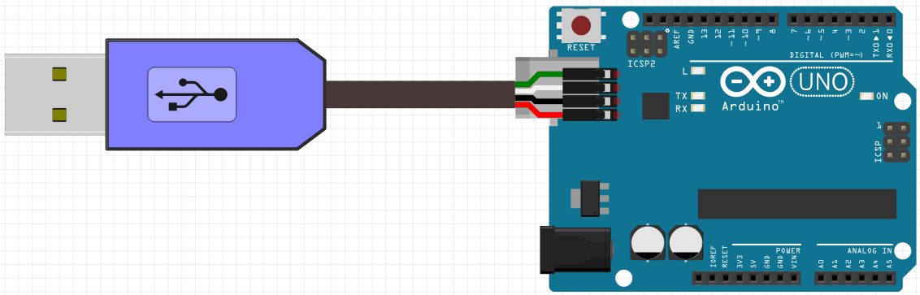[2]

|  |  |
| --- | --- |
| Remember, our instructions run in a loop from top to bottom, then back to the top again. |  |
| We will use two functions to control the RGB LED: | |
| **DigitalWrite**: makes a pin go HIGH or LOW. We can select two options: the pin number we want to control, and the state we want to set it to (HIGH or LOW). These options are called arguments. |  |
| **Delay:** makes the Arduino wait a number of milliseconds before continuing to the next instruction. There are 1000 milliseconds in one second. |  |

To program the Arduino, follow these 9 steps:

1. Open BlocklyDuino program and the Arduino IDE program.
2. Write instructions for the Arduino microcontroller using blocks in BlocklyDuino.
3. Click the “**Arduino**” tab in BlocklyDuino, select the code, and copy it
4. Go to the Arduino IDE and delete any code already there.
5. Paste the code from BlocklyDuino into the Arduino IDE.
6. Make sure the Arduino is connected to the computer using a USB cable
7. Click “**Tools**” on the top menu bar in the Arduino IDE, and make sure that “**Arduino UNO**” is selected under “**Board**”.
8. Click “**Tools**” on the top menu bar in the Arduino IDE, go to “**Port**”, and select the port that appears there after the Arduino is connected.
9. Click the arrow button  to upload the program to the Arduino

1. Icons made by [catkuro](https://www.flaticon.com/authors/catkuro) from [www.flaticon.com](https://www.flaticon.com/) is licensed by [CC 3.0 BY](http://creativecommons.org/licenses/by/3.0/).
2. Breadboard and Arduino images made using Fritzing.